Screenshot showing first heatmap in vacapy

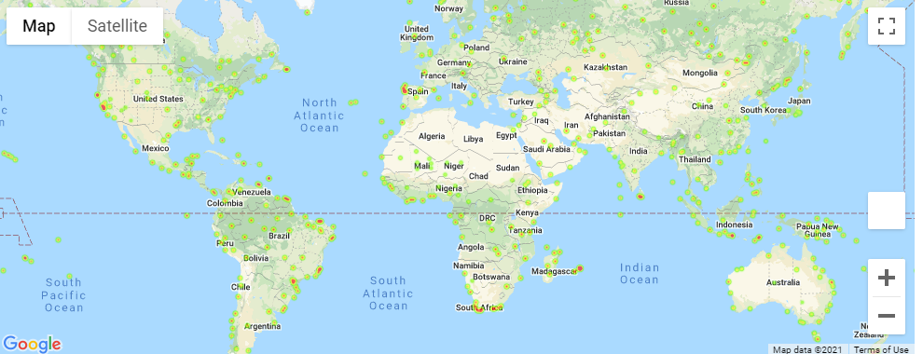

Screenshot 2 showing vacapy fig 2 with hotel info

